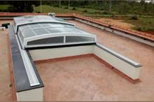 |  | 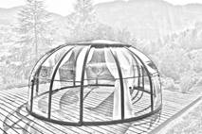 | 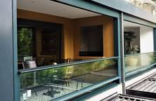 | 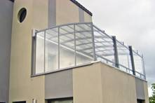
Automatic retractable roof - Add more splendour by allowing partial sunlight and night sky views. |  | Dome enclosure - Unique design for outdoor open-air-living. | Automatic vertical sliding window - Better utilization of space and even a better air ventilation scheme. | Balcony enclosure - Enhances the idea of open air sitting with panoramic view.
Website link: https://www.nihvaautomation.com/Product/automatic-sliding-roof  YouTube link: https://www.youtube.com/watch?v=ScpB-ZZbAcs |  | Website link: https://www.nihvaautomation.com/product/dome-enclosure | Website link: https://www.nihvaautomation.com/product/Automatic-Vertical-Sliding-Window  YouTube link: https://www.youtube.com/watch?v=SNjcjqMhGlY | Website link: https://www.nihvaautomation.com/product/Balcony-Enclosure
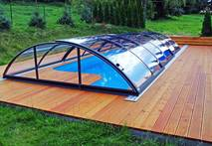 |  | 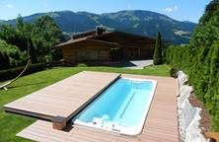 | 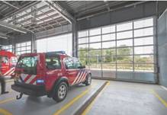 | 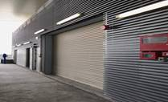
Swimming pool enclosure -  A modern way of safe keeping the pool from insects, creatures, dust and debris, thus saving on expensive cleaning chemical/labour |  | Swimming pool deck -  Automatic cover that doubles up the functioning the deck. | Garage sectional door - Good control over interior environment to create and maintain optimum air conditioning. | Fire rated rolling shutter - Close automatically on fire detection, and prevent the spread of fire and smoke.
Website link: https://www.nihvaautomation.com/product/Swimming-Pool-Enclosure |  | Website link: https://www.nihvaautomation.com/product/Swimming-Pool-Enclosure | Website link: https://www.nihva.com/product/glazed-overhead-doors  YouTube link: https://www.youtube.com/watch?v=9Tm8M-vJ_VM | Website link: https://www.nihva.com/product/fire-rated-rolling-shutters  YouTube link: https://www.youtube.com/watch?v=LNDEKy2buao
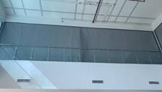 |  | 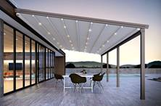 | 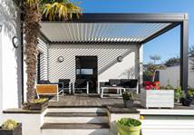 | 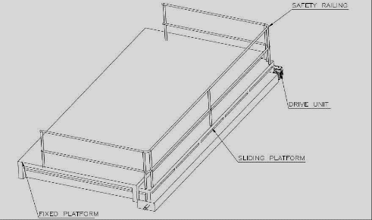
Fire curtain - The best equipment for compartmentalizing the building, isolating the hazardous and high-risk areas. |  | Retractable fabric roof (Pergola) - To create and outdoor luxurious, weather protected space. | Rotating louvers - Provides right amount of light and shed and protection from sun, rain and dew. | Retractable fire platform - A new innovation from NIHVA towards the safety of humanity.
Website link: https://www.nihva.com/product/fire-curtains
YouTube link: https://www.youtube.com/watch?v=UIaxQrarjOU
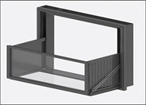
Foldable window balcony - An innovative product from NIHVA that converts the window into balcony.

Please refer the link for:

- Automatic Sliding roof:
Website link: https://www.nihvaautomation.com/Product/automatic-sliding-roof
YouTube link: https://www.youtube.com/watch?v=ScpB-ZZbAcs

- Dome enclosure
Website link: https://www.nihvaautomation.com/product/dome-enclosure

- Automatic vertical sliding window
Website link: https://www.nihvaautomation.com/product/Automatic-Vertical-Sliding-Window
YouTube link: https://www.youtube.com/watch?v=SNjcjqMhGlY

- Balcony enclosure
Website link: https://www.nihvaautomation.com/product/Balcony-Enclosure

- Swimming pool enclosure
Website link: https://www.nihvaautomation.com/product/Balcony-Enclosure

- Garage sectional door
Website link: https://www.nihva.com/product/glazed-overhead-doors
YouTube link: https://www.youtube.com/watch?v=9Tm8M-vJ_VM

- Fire rated rolling shutter
Website link: https://www.nihva.com/product/fire-rated-rolling-shutters
YouTube link: https://www.youtube.com/watch?v=LNDEKy2buao

- Fire curtain
Website link: https://www.nihva.com/product/fire-curtains
YouTube link: https://www.youtube.com/watch?v=UIaxQrarjOU

Pls find attached our Products along company introduction letter and client list for your reference. We are Confident to be a part of your Prestigious organization/Projects and look forward to hearing from you. For further any query please feel free to contact us.
We are also pleased to inform you that we undertake an AMC and Maintenance contract for all of our products & for any of your existing facilities.
Let’s work TOGETHER…

